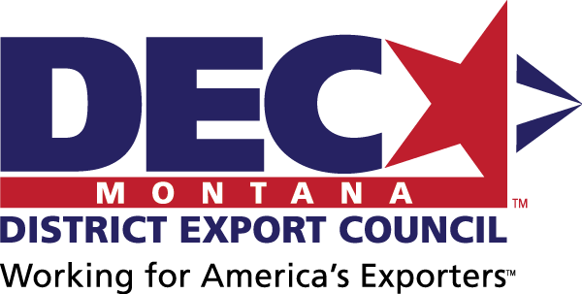
MINUTES
Montana District Export Council
September 6, 2018 | Bozeman, MT

DEC Mission Statement
The Montana DEC will support Montana exporters and provide a collective Montana exporter voice to advise on export education needs and disseminate education opportunities to its collective networks; and to advise policy makers on export policies under consideration and provide suggestions for future legislation.

In Attendance

Official DEC Members
Adam – Resonon, DEC Chair
Carey – US Commercial Service – Montana, DEC Executive Secretary
Mara – Enell
Bill – MacBride Law
Linda – PDT
Wendy – Diversified Plastics
Barry – Wood’s Powr Grip
Katie – Spika Welding

Export Resource Partners
Angie – ExportMontana, Montana Department of Commerce
Christy – Marketing Bureau, Montana Department of Agriculture
Jenni – Montana Manufacturing Extension Center
Wayne – Small Business Administration – Montana

Next Meeting
- Thursday, November 1, 2-4 pm, Montana Department of Commerce, 301 S. Park Ave., Helena, Room 226 (call Angie if you are having access issues: 431-5075), Call in: 877-309-2073, 500-367-085
- Tuesday, January 15, 2-4 pm, TBD, Kalispell (adjacent to Riddle of the Exporter training & ExporTech Session 1), Call in: 877 309 2073, 900-351-405

New Member
The DEC welcomed a new member: Christy Clark, the bureau chief of the Marketing Bureau in the Montana Department of Agriculture.

DEC Position Paper: Chinese Tariffs
The DEC reviewed the draft position paper on the imposition of Chinese tariffs. The final draft will be sent to all DEC members for final review and then sent to Montana’s Congressional Delegation. See Attachment 1 for the final draft.

DEC Website
The DEC website, housed within the Montana Department of Commerce’s website, will provide Montana exporters with export resources in support of the DEC mission. The final draft of the website is in Attachment 2.

Export Policies
DEC is currently reviewing the following export policies to assess their impact on Montana exports and the need for providing input to policy makers.

Currently under review:
- Chinese tariffs. DEC position paper drafted.

For future review:
- Steel and aluminum tariffs. Properly titled “Section 232 Investigation on the Effect of Imports of Steel on U.S. National Security”.
- Solar panel import tariffs. Regarding a unanimous ruling by the International Trade Commission (ITC) that U.S. solar-panel producers have been damaged by imports of crystalline silicon photovoltaic (CSPV) cells.

Exporter of the Year Award
The DEC reviewed the Montana Exporter of the Year application and guidelines. Final draft of both are available in Attachment 3.

Upcoming Events
Date | Event | Location | Sponsor
10/2/2018 | SME Lean Bronze Fall 2018 | Missoula | MMEC
11/1/2018 | DEC meeting, 2-4 pm  - Call in: 877-309-2073, 500-367-085 | Montana Dept of Commerce, Helena | DEC
12/10-12/2018 | IQA ISO 13485 | TBD | MMEC
12/19/2018 | Preventative Controls Qualified Individual PCQI 2018 | Bozeman | MMEC
1/15/2016 | DEC meeting, 2-4 pm  - Call in: 877 309 2073, 900-351-405 | Kalispell | DEC
1/16/2019 | Riddle of the Exporter Training / ExporTech Session 1 | Kalispell | MMEC, ExportMontana

Attachment 1: DEC Position Paper
ADAM INSERT FINAL DRAFT HERE.

Attachment 2: MT DEC Draft Website

Home

Home | About Us | Upcoming Events | Exporter of the Year | Export Resources | Contact Us

Montana DEC Mission
The Montana DEC will support Montana exporters and provide a collective Montana exporter voice to advise on export education needs and disseminate education opportunities to its collective networks; and to advise policy makers on export policies under consideration and provide suggestions for future legislation.

About Us

Current Members

Resonon, Inc. | Bozeman
Adam Stern Chair
406-586-3356 x116 | stern@resonon.com
www.resonon.com

U.S. Commercial Service, Montana Export Assistance Center | Helena
Carey Hester Executive Secretary
406-370-0097 | carey.hester@trade.gov

Satic USA | Missoula
B.D. Erickson Vice Chair
406-493-1861 | bd@saticusa.com
www.saticusa.com

Agmor Inc. | Belgrade
Kyle Lukes
406-388-4403 | kylelukes@hotmail.com
www.agmorinc.com

Ascent Vision Technologies, LLC | Belgrade
Joel Pineiro
443-286-9326 | j.pineiro@ascentvision.com
www.ascentvision.com

Crowley Fleck PLLP | Bozeman
Samuel Frederick
406-522-4547 | sfrederick@crowleyfleck.com
www.crowleyfleck.com

Diversified Plastics, Inc. | Missoula
Wendy Koster
406-543-6653 | wkoster@diversifiedplastics.net
www.diversifiedplastics.net

Enell, Inc. | Havre
Mara Osborne
406-265-8250 | mara.osborne@enell.com
www.enell.com

ExportMontana - Montana Department of Commerce | Helena
Angelyn DeYoung
406-841-2783 | adeyoung@mt.gov
exportmontana.com

MacBride Law, PLLC | Bozeman
William MacBride
406-577-2777 | wlm@macbridelaw.com
www.macbridelaw.com

Montana Manufacturing Extension Center | Bozeman
Jennifer West
406-994-3876 | jenniwest@montana.edu
www.montana.edu/mmec

MounTerra, Inc. | Missoula
Brigitta Miranda-Freer
406-544-0127 | brigitta@mounterra.com

PDT, Inc. | Missoula
Linda Miller
406-544-2620 | lindam@pdtdental.com
www.pdtdental.com

Resodyn Acoustic Mixers | Butte
Tibor Egervary
406-497-5401 / 406-565-2363 (C) | tibor.egervary@resodyn.com
www.resodynmixers.com

Spika Design & Manufacturing, Inc. | Lewistown
Katie Spika
406-535-5678 | katie.spika@spikamfg.com
www.spikamfg.com

The Law Office of Richard Hegger | Somers
Richard Hegger
406-890-4678 | Richardhegger@heggerlaw.com

TowHaul Corporation | Belgrade
Dianna Kegel
406-388-3424 | dkegel@towhaul.com
www.towhaul.com

Wood's Powr-Grip Co., Inc. | Laurel
Barry Wood
406-628-8231 | barryw@wpg.com
www.wpg.com

Become a Member
Contact Carey Hester, U.S. Commercial Service, Montana Export Assistance Center, to inquire about Montana District Export Council membership.

Archives
DEC meeting minutes
DEC position papers

Upcoming Events
Link to ExportMontana’s upcoming events page

Exporter of the Year
In recognition of Montana companies for their contribution to the state’s economic growth and prosperity through the sale of Montana products or services abroad, the Montana District Export Council is proud to award Exporter of the Year annually.

Guidelines & Application
links to cover letter/application/guideline (see Attachment 3)

Past Awardees
Year | Company Name (hyperlink to website), City

Export Resources

8 Steps to Exporting
Click on the topics below to learn more about the 8 steps to exporting.
- Getting Started
- Market Research
- Market Entry
- Legal
- Compliance
- Transportation
- Payment and Finance
- Cultural

Montana Exporter Support
Montana is lucky to have a great group of export partners, ready to help Montana companies with their international sales and marketing plans.

ExportMontana
The Montana Department of Commerce’s ExportMontana helps Montana exporters with getting started, market research, market entry, legal, compliance, transportation, and cultural considerations.
http://marketmt.com/export

Export-Import Bank (ExIm) – Western Region
The Export-Import Bank of the United States (EXIM) is the official export credit agency of the United States, offering export financing tools and export credit risk insurance.
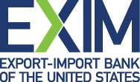 https://grow.exim.gov/sandra-donzella

Montana Chamber of Commerce
The Montana Chamber of Commerce promotes legislation that supports Montana businesses, and offer programs, services and action to educate members, improve their businesses and accelerate change. They also provide Certificates of Origin for Exporting (scroll down the page a bit).
https://www.montanachamber.com/

Montana Department of Agriculture
The Montana Department of Agriculture’s International Marketing Office helps Montana companies selling agricultural products by providing training on entering international markets, developing personalized export development plans, organizing trade missions, and assisting in the attendance of international trade shows. They also link Montana agricultural companies to the WUSATA program grants for international marketing.
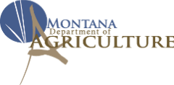 https://agr.mt.gov/

Montana District Export Council
The Montana District Export Council supports Montana exporters and provides a collective Montana exporter voice to advise on export education needs and disseminate education opportunities to its collective networks; and advises policy makers on export policies under consideration and provide suggestions for future legislation.
link to this page

Montana Manufacturing Extension Center
MMEC is a statewide manufacturing outreach and assistance center that helps manufacturers succeed by assessing their operations and providing insight and solutions to help them grow, innovate and enhance their businesses.
http://www.montana.edu/mmec/

Montana Small Business Development Centers
The SBDC network supports ten centers around the state, focusing on counseling in areas such as financial analysis, business planning, training and workshops and loan packaging assistance to help small businesses achieve their goals of growth, expansion, innovation and success.
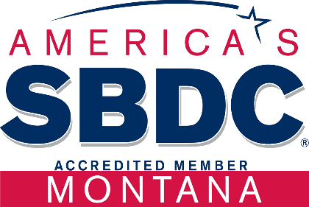 http://sbdc.mt.gov/

Montana World Trade Center
The Montana World Trade Center provides Montana companies with actionable information, prescriptive export strategies, on-demand project management, and long-term strategic guidance.
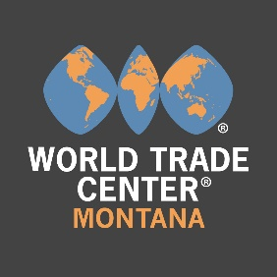 http://www.mwtc.org/

National Association of District Export Councils
The National Association of District Export Councils (NADEC) increases awareness and understanding of the importance of exports to the US economy through education, legislative outreach and engagement with DECs and other relevant stakeholders.

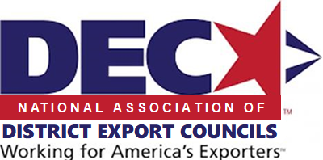 http://www.districtexportcouncil.org/

US Export Assistance Center – Montana
The US Export Assistance Center – Montana provides trusted market intelligence, practical advice and business tools to help you understand how to export, connect with foreign buyers, and expand operations in new markets.
https://www.export.gov/

US Small Business Administration – Montana
Most U.S. banks view loans for exporters as risky. This can make it harder for you to get loans for things like day-to-day operations, advance orders with suppliers, and debt refinancing. That’s why the SBA created programs to make it easier for U.S. small businesses to get export loans.
https://www.sba.gov/offices/district/mt/helena

Contact Us
Adam Stern, DEC Chair
BD Erickson, DEC Vice Chair
Carey Hester, DEC Executive Secretary

Attachment 3: Exporter of the Year Application

MONTANA DISTRICT EXPORT COUNCIL
10 West 15th Street, Suite 1100
Helena, Montana 59626

DATE

Montana Exporter:

The Montana District Export Council (MDEC) is seeking nominations for the YEAR State of Montana Exporter of the Year Award. This award recognizes a Montana firm that has made a significant contribution to the economic growth and prosperity of the state through its international marketing activities. All Montana firms that sell products or services in foreign markets are encouraged to apply.

The official Montana Exporter of the Year nomination form is attached to this cover letter, but nominations may be submitted without this form if they include the data requested on the official nomination form. Exporters may nominate themselves for the award.

All nominations should be sent to Angelyn DeYoung, member of the MDEC, at ADeYoung@mt.gov.

The deadline for nominations is DATE.

If you have any questions about the nomination process, please contact one of the DEC officers below:
- Adam Stern, Resonon, MDEC Chair: 406-586-3356 x116 or stern@resonon.com
- BD Erickson, Satic USA, MDEC Vice Chair: 406-493-1861 or bd@saticusa.com
- Carey Hester, MDEC Executive Secretary: 406-370-0097 or Carey.Hester@trade.gov
- Angelyn DeYoung, Montana Dept of Commerce: 406-841-2743 or ADeYoung@mt.gov

The Montana DEC will support Montana exporters and provide a collective Montana exporter voice to advise on export education needs and disseminate education opportunities to its collective networks; and to advise policy makers on export policies under consideration and provide suggestions for future legislation.

Sincerely,

Signature here

Adam Stern, MDEC Chair

YEAR MONTANA EXPORTER
OF THE YEAR AWARD
In recognition of Montana companies for their contribution to the state’s economic growth and prosperity through the sale of Montana products or services abroad

NOMINEE INFORMATION
Company Name
Company Contact & Title |  |  |  | Phone
Email |  |  |  | Website
Are Company Headquarters in Montana?  Only exporters with principle operations in Montana will be considered. |  |  |  |  |  |  |  | Yes |  |  | No
Street Address
City, State, Zip
Number of Montana Employees
Montana Exporters with Montana employee growth will receive priority consideration.
2016 |  |  | 2017 |  |  | 2018
Product(s) / Service(s) Exported
What percent of the product’s / service’s value was added in Montana?  Only exporters whose products / services with significant value-added in Montana will be considered. |  |  |  |  |  |  |  |  |  | %

Total Revenue from Montana Exports
Montana Exporters with Montana export revenue growth will receive priority consideration.
2016 | 2017 |  | 2018
$ | $ |  | $
enter export % of total revenue here | enter export % of total revenue here |  | enter export % of total revenue here
Countries Montana Product Exported To
Please list the top 10 countries.
Montana Exporters selling Montana products to multiple countries will receive priority consideration.
Company Narrative
Please tell us about your company as a Montana exporter (limit: 1000 words).
Montana Exporters with significant economic and/or social impact on local or Montana communities will receive priority consideration.
Other Comments (optional)

NOMINATED BY (if different from nominee)
Company / Organization Name
Contact & Title |  | Phone
Email |  | Website
SUBMISSION
Due by: DATE
Send to: Angelyn DeYoung
Mail: Montana Department of Commerce, PO Box 200505, Helena, MT 59620-0505
Fax: 406-841-2871
Email: adeyoung@mt.gov (no larger than 5 MB)
Applicants may be contacted for additional details as needed.

EXPORTER OF THE YEAR GUIDELINES
Required Qualifications:
- Only exporters with principle operations in Montana will be considered.
- Only exporters whose products / services with significant value-added in Montana will be considered.
Preferred Qualifications:
- Montana Exporters with Montana employee growth will receive priority consideration.
- Montana Exporters with Montana export revenue growth will receive priority consideration.
- Montana Exporters selling Montana products to multiple countries will receive priority consideration.
- Montana Exporters with significant economic and/or social impact on local or Montana communities will receive priority consideration.

