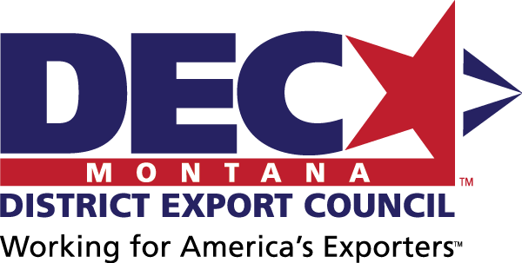
MINUTES
Montana District Export Council
May 15, 2019 | Kalispell, MT

DEC Mission Statement
The Montana DEC will support Montana exporters and provide a collective Montana exporter voice to advise on export education needs and disseminate education opportunities to its collective networks; and to advise policy makers on export policies under consideration and provide suggestions for future legislation.

Attendees

Official DEC Members*
Adam – Resonon, DEC Chair
Diana – TowHaul
Richard – The Law Office of Richard Hegger
Katie – Spika Manufacturing
Carey – US Commercial Service
Angie – Montana Dept of Commerce-ExportMontana
*Official DEC membership, controlled by the US Department of Commerce – International Trade Administration, can be accepted in June in even-numbered years.

Guests
Scott – Rocky Mountain Bank
Webb Brown

Export Resource Partners
Canon – Montana Dept of Commerce-ExportMontana
Jenni – Montana Manufacturing Extension Center
Brigitta – Montana World Trade Center

Next Meeting
Hamilton, MT: Export 101 Training, 9-11 am | DEC Meeting, 2-4 pm, Wednesday, September 11
In person: Ravalli County EDA (requested, awaiting confirmation), 274 Old Corvallis Rd, Hamilton. Area exporters will be invited as guests for future DEC membership.
Call-in: 877-309-2073, Access Code: 640-952-093
Agenda items will include:
- Welcome to DEC chair BD and Vice Chair Barry
- Quarterly DEC meetings schedule (last Thurs of the month in Jan, Apr, Jul, Oct)
- FX by Bannockburn
- USMCA update
- 301 Investigation & Chinese tariffs update
- Section 232 investigation & steel/aluminum tariffs update
- Exporting webinars update
- STEP update
- NADEC update
- Workshop on export checklist

Treasurer’s Report
Brigitta presented the Treasurer’s Report, and it was approved with $337 as the balance.

USMCA Update
The proposed replacement for NAFTA, US-Mexico-Canada Agreement (USMCA), is currently under consideration by Congress, with a vote anticipated in August 2019. Until its approval, NAFTA remains in place.
Carey indicated that it is not that much different from NAFTA as it relates to Montana, except for in the Agricultural sector (grains, dairy, etc.). The Montana USMCA impact fact sheet is available for download. The Montana World Trade Center’s USMCA webinar will be available for viewing.

NADEC Update
Adam will officially notify the NADEC that Richard is Montana’s representative. Richard and Adam will both participate as members in the NADEC’s international trade policy committee.

Exporter Webinars Update
DEC will support the following export training topics via webinar (then recorded for on-demand on the DEC website):

Pending
- Export 101 (ExportMontana) – 2 pilot presentations in Great Falls and Kalispell in April/May. Will host in Hamilton in September. Available for additional presentations statewide as requested.
- Recent US Trade Policy – How Does It Affect Me? (USCS) – June. This topic will cover:
  - Chinese tariffs
  - Steel and aluminum tariffs
- International Shipping (ExportMontana)
- International Risk Management & Payment Methods (SBA)
- Foreign Exchange (MWTC) – discuss at next DEC meeting
- Export Process from Request for Quote to Shipment (USCS & ExportMontana) – this checklist in the development process; Diana will review. Carey will send to all official DEC members for additional input at the September meeting. Once finalized, USCS/ExportMT will offer a webinar.

Completed
- USMCA (MWTC)

Postponed
- Free Trade Agreements & Tariffs (USCS)
- International Standards, e.g. CE Mark, etc. (USCS)

STEP Grant FFY 19 Update
ExportMontana will submit the STEP grant Federal fiscal year 2019 application at the end of May, anticipating approval by mid-September.
- Funding grants for individual Montana exporters for:
  - International Trade Show Exhibition – up to $10,000 reimbursement + up to $2,000 travel stipend
  - Language Translation Services & Production Fees – up to $3,000 reimbursement
  - U.S. Commercial Service Programs – up to $5,000 reimbursement + up to $2,000 travel stipend
  - International Compliance Testing – up to $3,000 reimbursement
  - Montana Online Global Program – up to $3,000 reimbursement
  - International Travel Stipend – up to $2,000 reimbursement
- Hosting Montana Pavilions for Montana exporter industry groups:
  - Nov 2019, Milipol Paris, security and defense industry
  - Mar 2020, IWA Outdoor, outdoor and hunting industry
  - Jun 2020, Japan Fishing Show, flyfishing products and services
  - 2020, building and construction industry show in Canada (TBD)
DEC indicated support for the plan and will help disseminate program information to Montana exporters.

DEC Administration
Adam stepped down as Chair. We thank Adam for his meritorious service to the DEC and its reformation!
BD is appointed as Chair, and Barry is appointed as Vice Chair.

Exporter of the Year Award
DEC hosted the Exporter of the Year Award Ceremony at ClassOne Technology, the award winner, in Kalispell.

