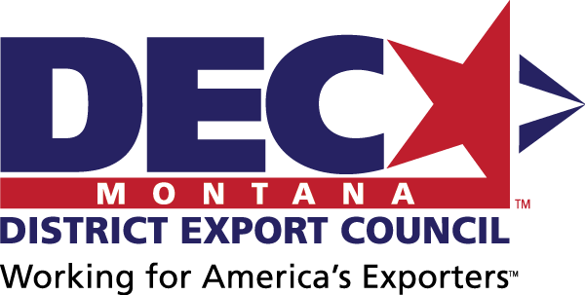
MINUTES
Montana District Export Council
February 20, 2019 | Billings, MT

DEC Mission Statement
The Montana DEC will support Montana exporters and provide a collective Montana exporter voice to advise on export education needs and disseminate education opportunities to its collective networks; and to advise policy makers on export policies under consideration and provide suggestions for future legislation.

In Attendance

Official DEC Members
Adam – Resonon, DEC Chair
B.D. – Satic USA, DEC Vice Chair
Mara – Enell
Barry – Wood’s Powr Grip
Diana – TowHaul
Tibor – Resodyn
Richard – The Law Office of Richard Hegger
Bill MacBride – MacBride Law, PLLC
Joel – Ascent Vision Technologies

Guests
Susan – Tabletree Juice
Dave – Ideal Mfg.

Export Resource Partners
Wayne – Small Business Administration – Montana
Carey – US Commercial Service – Montana
Angie – ExportMontana, Montana Department of Commerce
Brigitta – Montana World Trade Center

Next Meeting
2-4 pm, Wednesday, May 15, adjacent to Montana Exporter of the Year Award Ceremony
In person: To be determined; dependent upon Exporter of the Year Award recipient’s home town. Area exporters will be invited as guests for future DEC membership. Additionally, each DEC member will invite at least one exporter of their acquaintance to attend the DEC meeting to encourage future DEC membership.
Call-in: TBD
Agenda items will include:
- Exporter of the Year Award ceremony
- USMCA update
- NADEC update
- Exporter webinars update
- STEP grant FFY 19 update

Minutes
Minutes were presented and approved.

Treasurer’s Report
Treasurer’s report was presented and approved with $337 as the balance.

Public Comments
Time for public comment was offered; none provided.

USMCA
The proposed replacement for NAFTA, US-Mexico-Canada Agreement (USMCA), is currently under consideration by Congress.
The Montana Fact Sheet, created by the Office of the US Trade Representative, provides a Federal perspective on potential impacts. Additionally, Brigitta will send additional information on the Montana World Trade Center’s March 28th webinar for more insights.

Exporter of the Year Award
The official DEC members reviewed the 5 Montana Exporter of the Year award applications from:
- ClassOne Technology
- H-E Parts International - Mining Solutions
- R.L. Winston Rod Co.
- HCR, Inc.
- Burgi Engineers
DEC deliberated on the applications and decided to utilize a scoring matrix to determine the EOTY winner. DEC members will submit scores to Angie for recording by February 21, and Angie will return the results to DEC membership for final deliberations and to determine the EOTY winner by early April.
DEC decided that the EOTY award ceremony will take place mid-May in the home town of the winner. Angie will coordinate with the winner on the date and location and update the DEC, as well as coordinate a press release and local media invitation.

NADEC Trade Policy Advocacy Liaison
DEC appointed Richard Hegger as its National DEC Trade Policy Advocacy Liaison.

Continuing Education Seminars
DEC will support the following export training topics via webinar:
- International Shipping (ExportMontana)
- Free Trade Agreements & Tariffs (USCS)
- International Standards, e.g. CE Mark, etc. (USCS)
- International Risk Management & Payment Methods (SBA)
- Foreign Exchange (MWTC)
- USMCA (MWTC)

Montana STEP Grant Plans
Angie presented ExportMontana’s draft plan for the Federal FY19 STEP grant application:
- Funding grants for individual Montana exporters for:
  - International Trade Show Exhibition – up to $10,000 reimbursement + up to $2,000 travel stipend
  - Language Translation Services & Production Fees – up to $3,000 reimbursement
  - U.S. Commercial Service Programs – up to $5,000 reimbursement + up to $2,000 travel stipend
  - International Compliance Testing – up to $3,000 reimbursement
  - Montana Online Global Program – up to $3,000 reimbursement
  - International Travel Stipend – up to $2,000 reimbursement
- Hosting Montana Pavilions for Montana exporter industry groups:
  - Nov 2019, Milipol Paris, security and defense industry
  - Mar 2020, IWA Outdoor, outdoor and hunting industry
  - Jun 2020, Global Petroleum Show, oil fields and oil sands industry
  - 2020, (show TBD via Montana Photonics Industry Alliance), photonics industry
DEC indicated support for the plan and will help disseminate program information to Montana exporters.

DEC Website
There is a temporary DEC website available at http://marketmt.com/Export/MontanaDEC. Upon restructuring of the ExportMontana website, additional resources for exporters will be available.

New DEC Membership
DEC membership is capped at 30 members and should represent a cross-section of the state’s export industries.
To encourage new DEC membership, Angie will encourage exporters local for each DEC meeting to attend in person. Additionally, DEC members will each invite at least one exporter to the May DEC meeting.
Official DEC membership can be accepted in June in even-numbered years.

