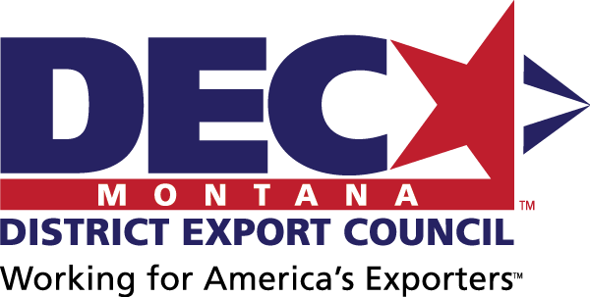
MINUTES
Montana District Export Council
January 15, 2019 | Kalispell, MT

DEC Mission Statement
The Montana DEC will support Montana exporters and provide a collective Montana exporter voice to advise on export education needs and disseminate education opportunities to its collective networks; and to advise policy makers on export policies under consideration and provide suggestions for future legislation.

In Attendance

Official DEC Members
Adam – Resonon, DEC Chair
Mara – Enell
Wendy – Diversified Plastics
Barry – Wood’s Powr Grip
Diana – TowHaul

Guests
Tom – Glacier Hops Ranch
Gary & Susan – Tabletree Juice
Todd – Mountain Meadow Herbs

Export Resource Partners
Angie – ExportMontana, Montana Department of Commerce
Katie – ExportMontana, Montana Department of Commerce
Brigitta – Montana World Trade Center

Next Meeting
2-4 pm, Wednesday, February 20
In person: Wood’s Pow-r Grip, 908 W Main St, Laurel (factory tour follows). Area exporters will be invited as guests for future DEC membership.
Call-in: 866-899-4679, Access Code: 249-445-853
Agenda items will include:
- Exporter of the Year Award application reviews and award ceremony planning
- DEC outreach and referral
- National DEC priorities
- USMCA summary and DEC encouraging it to pass
- Bannockburn to present on foreign exchange
- Exporter survey
- Montana STEP grant and additional exporter resources
- Additional DEC member recruitment and future activities

Minutes
Minutes were presented and approved.

Treasurer’s Report
Treasurer’s report was presented and approved with $337 as the balance.

Public Comments
Time for public comment was offered; none provided.

Presidential E-Award
The Presidential E-Award provides Presidential recognition for achievements in growing exports. The DEC encourages Montana companies to apply. The deadline is January 25. See attached.

Exporter of the Year Award
The Montana Exporter of the Year Award applications are due DATE. Angie will encourage exporters to apply, and the DEC will review the applications at the February meeting.

Policy Initiatives for Building Human Capital in Montana
DEC attendees provided input:
- Shipping consolidation for better rates: DEC members would like to explore this at future meetings.
- International shipping training: ExportMontana is preparing training on international shipping, including topics such as carriers, expediters, customs brokers, best practices, etc. The training will be recorded and offered on-demand on the DEC website.

301 Position Paper
The 301 Position Paper, representing the DEC’s position against the use of tariffs to settle trade disputes, was sent to Montana’s Congressional offices. No response has been received yet; Adam will confirm receipt and encourage response.
Angie will add the paper to the DEC website.

California DEC Activities for Consideration
Differences and similarities between the Montana and California DECs were presented. Most notably, CA DEC is not political and focuses mostly on supporting US Department of Commerce’s activities.

DEC Website
There is a temporary DEC website available at http://marketmt.com/Export/MontanaDEC. Upon restructuring of the ExportMontana website, additional resources for exporters will be available.

Survey
The Montana exporter survey has been tabled until a future meeting.

USMCA
The proposed replacement for NAFTA, US-Mexico-Canada Agreement (USMCA), is currently under consideration by Congress. At the next meeting, DEC will urge Congress to pass the renegotiated agreement. In the meantime, the DEC encourages members to individually contact their legislators to do the same.
Katie and Brigitta will send their summaries of the agreement and its impact on Montana exporters. Brigitta will send additional information on the Montana World Trade Center’s upcoming webinar.

New DEC Membership
To encourage new DEC membership, Angie will encourage exporters local for each DEC meeting to attend in person. Official DEC membership can be accepted in June annually.

