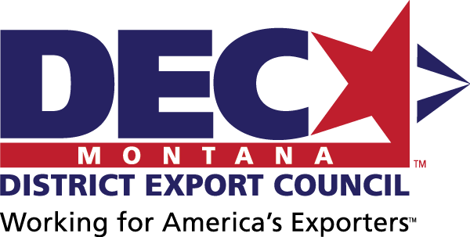

MONTANA DISTRICT EXPORT COUNCIL
10 West 15th Street
Suite 1100
Helena, Montana 59626

December 1, 2020

Montana Exporter:

The Montana District Export Council (MDEC) is seeking nominations for the 2020 State of Montana Exporter of the Year Award. This award recognizes a Montana firm that has made a significant contribution to the economic growth and prosperity of the state through its international marketing activities. All Montana firms that sell products or services in foreign markets are encouraged to apply.

The official Montana Exporter of the Year nomination form is attached to this cover letter, but nominations may be submitted without this form if they include the data requested on the official nomination form. Exporters may nominate themselves for the award.

All nominations should be sent to Angelyn DeYoung, member of the MDEC, at ADeYoung@mt.gov.

The deadline for nominations is March 1, 2021.

If you have any questions about the nomination process, please contact one of the DEC officers below:
- Carey Hester, MDEC Executive Secretary: 406-370-0097 or Carey.Hester@trade.gov
- Angelyn DeYoung, Montana Dept of Commerce: 406-841-2743 or ADeYoung@mt.gov

The Montana DEC will support Montana exporters and provide a collective Montana exporter voice to advise on export education needs and disseminate education opportunities to its collective networks; and to advise policy makers on export policies under consideration and provide suggestions for future legislation.

Sincerely,

Barry Wood, MDEC Chair

2020 MONTANA EXPORTER
OF THE YEAR AWARD
In recognition of Montana companies for their contribution to the state’s economic growth and prosperity through the sale of Montana products or services abroad

NOMINEE INFORMATION
Company Name
Company Contact & Title |  |  |  |  |  | Phone
Email |  |  |  |  |  | Website
Are Company Headquarters in Montana?  Only exporters with principle operations in Montana will be considered. |  |  |  |  |  |  |  |  |  |  | Yes |  |  | No
Street Address
City, State, Zip
Number of Montana Employees
Montana Exporters with Montana employee growth will receive priority consideration.
2017 |  |  | 2018 |  |  |  |  |  | 2019
Product(s) / Service(s) Exported
Schedule B # of products exported
Contact ExportMontana for help with this #, if needed
What percent of the product’s / service’s value was added in Montana?  Only exporters whose products / services with significant value-added in Montana will be considered. |  |  |  |  |  |  |  |  |  |  |  |  | %
Total Revenue from Montana Exports
Montana Exporters with Montana export revenue growth will receive priority consideration.
2017 |  |  |  | 2018 |  |  |  | 2019
$ |  |  |  | $ |  |  |  | $
enter export % of total revenue here |  |  |  | enter export % of total revenue here |  |  |  | enter export % of total revenue here
Countries Montana Product Exported To
Please list the top 10 countries.
Montana Exporters selling Montana products to multiple countries will receive priority consideration.
Company Narrative
Please tell us about your company as a Montana exporter (limit: 1000 words).
Montana Exporters with significant economic and/or social impact on local or Montana communities will receive priority consideration.
Other Comments (optional)

NOMINATED BY (if different from nominee)
Company / Organization Name
Contact & Title |  | Phone
Email |  | Website
SUBMISSION
Due by: March 1, 2021
Send to: Angelyn DeYoung
Mail: Montana Department of Commerce, PO Box 200505, Helena, MT 59620-0505
Fax: 406-841-2871
Email: adeyoung@mt.gov (no larger than 5 MB)
Applicants may be contacted for additional details as needed.

EXPORTER OF THE YEAR GUIDELINES
Required Qualifications:
- Only exporters with principle operations in Montana will be considered.
- Only exporters whose products / services with significant value-added in Montana will be considered.
Preferred Qualifications:
- Montana Exporters with Montana employee growth will receive priority consideration.
- Montana Exporters with Montana export revenue growth will receive priority consideration.
- Montana Exporters selling Montana products to multiple countries will receive priority consideration.
- Montana Exporters with significant economic and/or social impact on local or Montana communities will receive priority consideration.

